Sonar prediction

# Algorithm

Logistic Regression

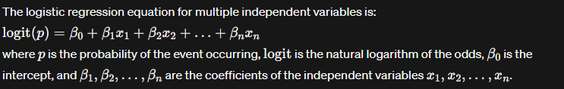

1. Import libraries

* Pandas,numpy
* From sklearn import for ML model, accuracy score, train_test_split

1. Data preprocessing

* Handling missing values
* Since the 60th column is related to the Y for the we drop the 60th column and retrive other data for the X

(if we are droping a column axis is 1 if we are droping a row axis=0)

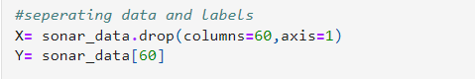

1. Split data into Train and test
2. Model training
3. Model evaluvation
4. Creating a Prediction system